1 Please provide a list of 10 classic English-language movies. Please highlight the important words to the semantic meanings in every sentence using boldface fonts.

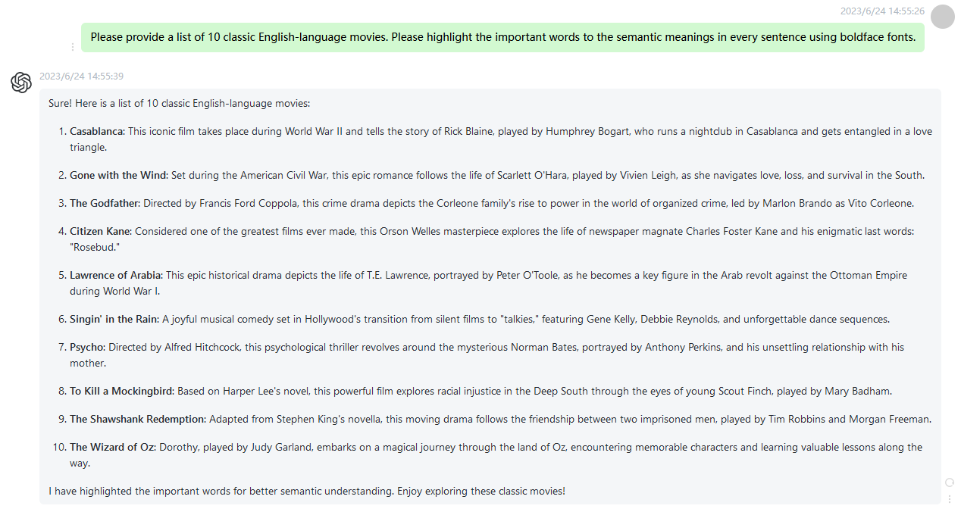

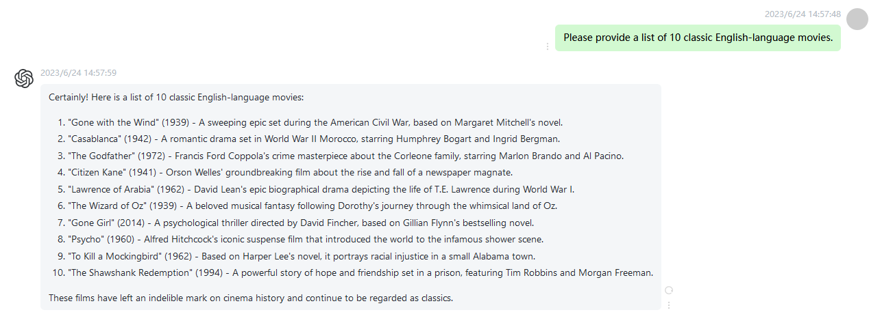

2 Please provide a list of 10 most influential scientists. Please highlight the important words to the semantic meanings in every sentence using boldface fonts.

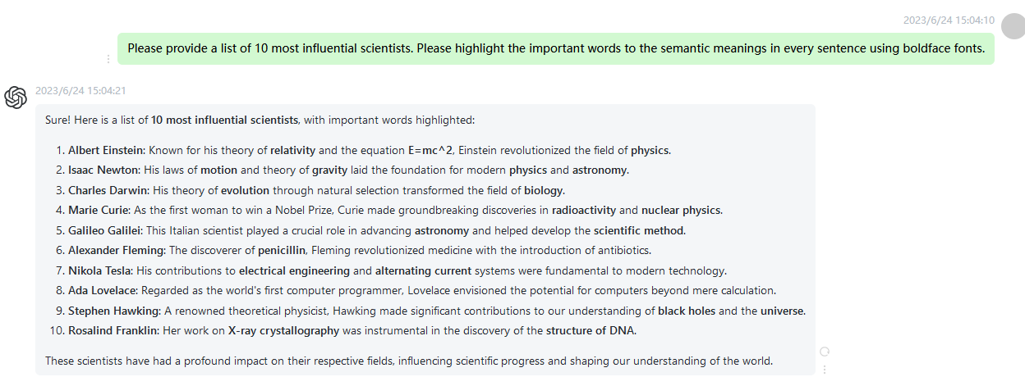

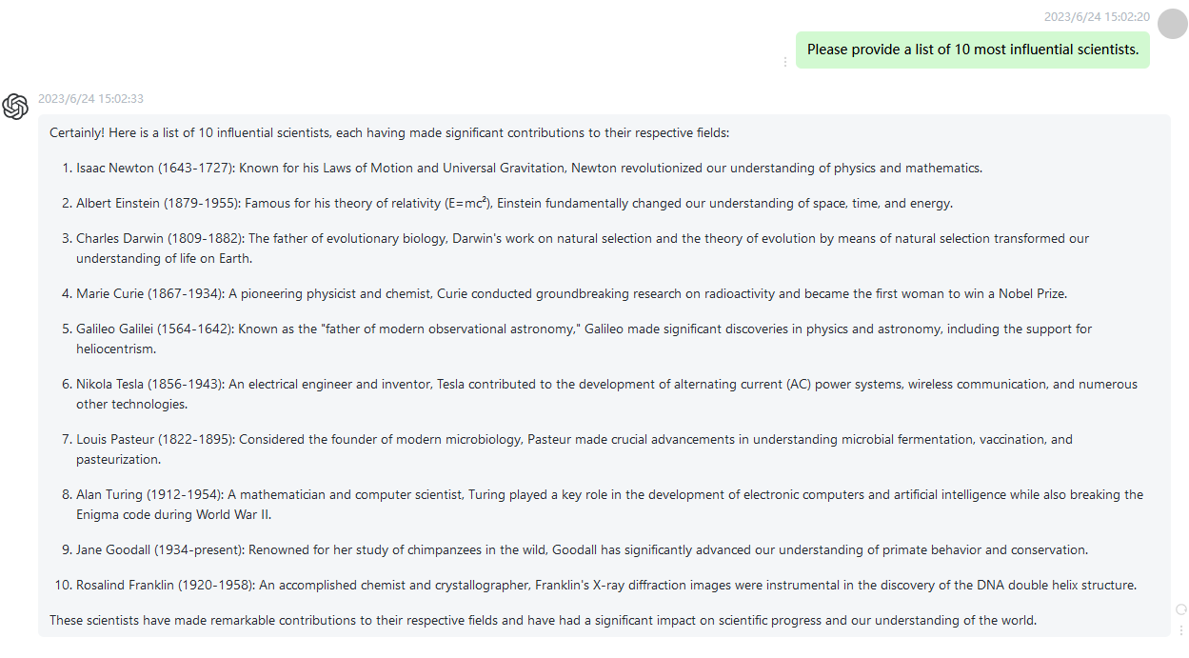

3 Please provide a list of the top 5 most beautiful places in the world. Please highlight the important words to the semantic meanings in every sentence using boldface fonts.

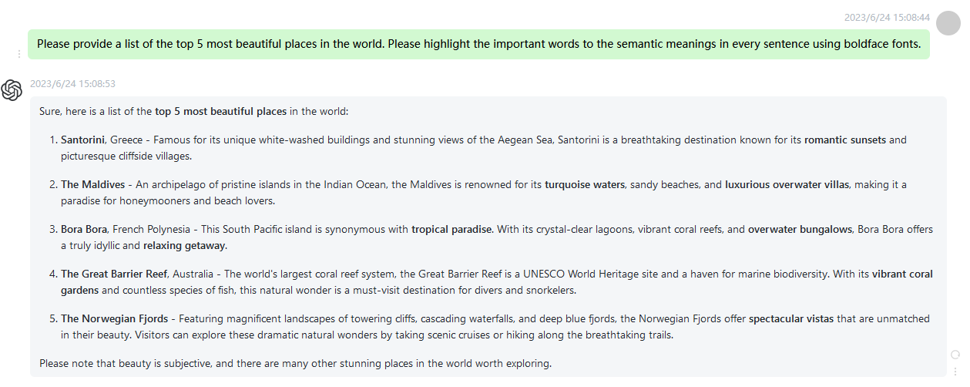

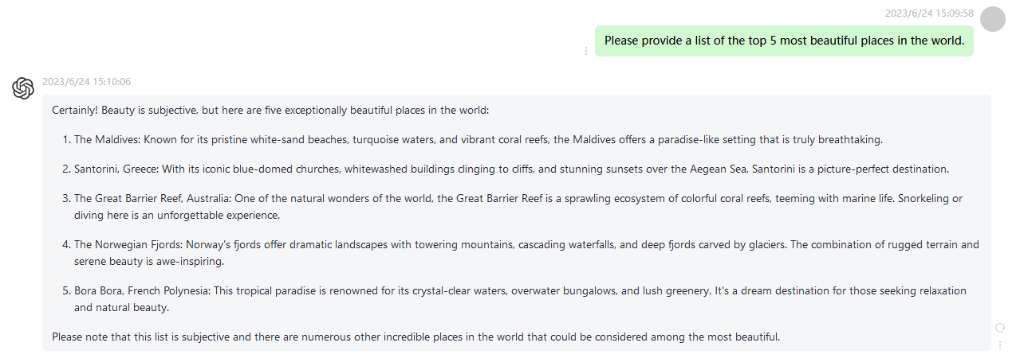

4 Please provide three of Vincent van Gogh's most representative artworks. Please highlight the important words to the semantic meanings in every sentence using boldface fonts.

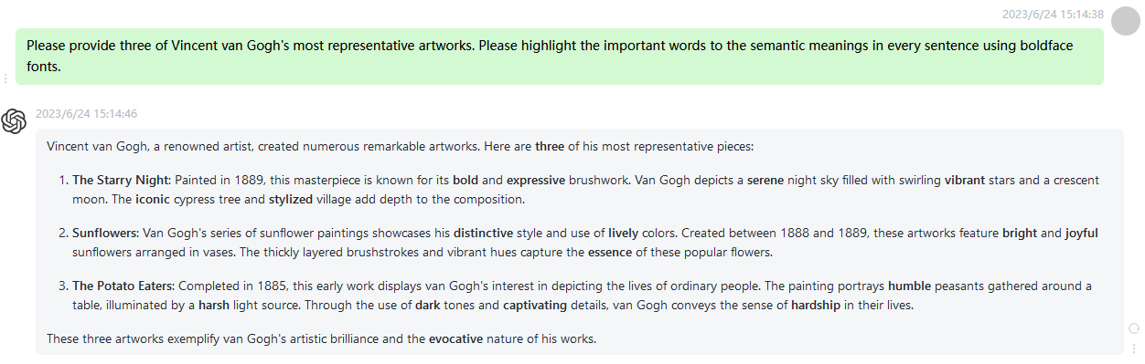

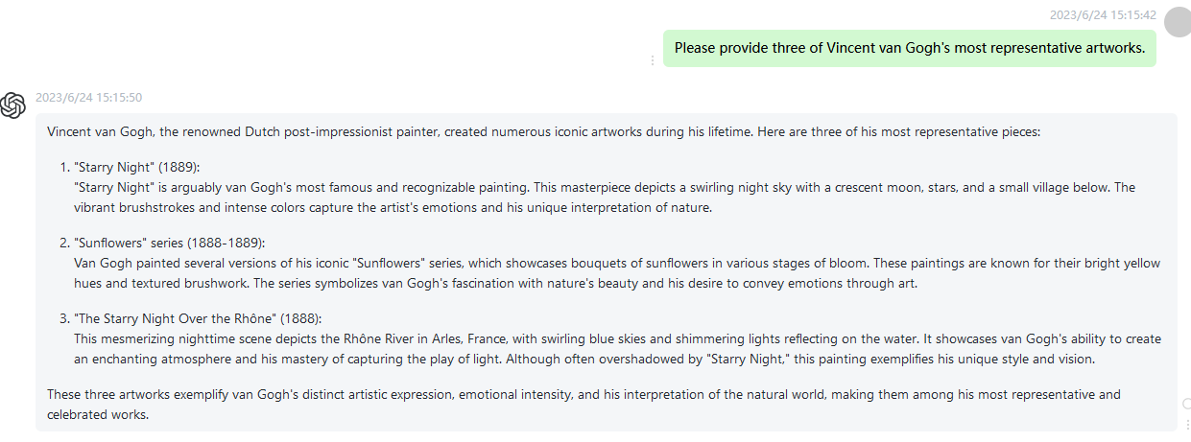

5 Please provide a list of the top 10 most popular Chinese singers. Please highlight the important words to the semantic meanings in every sentence using boldface fonts.

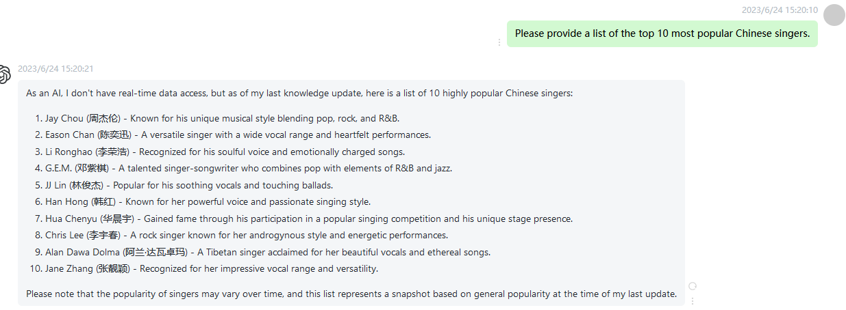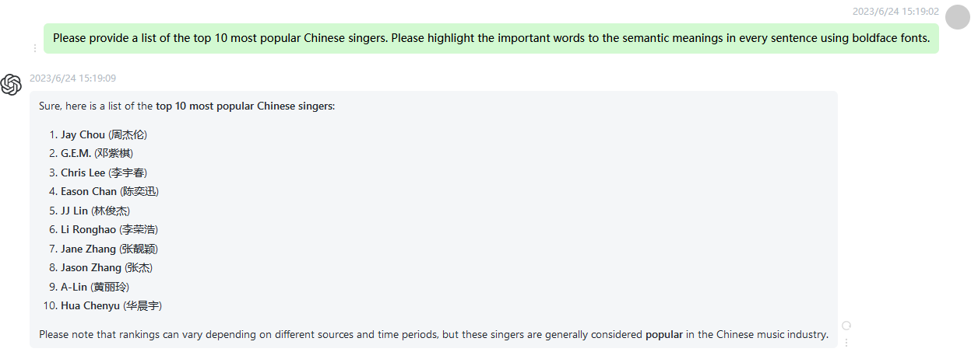

6 What is the ultimate vision of 6G? Please highlight the important words to the semantic meanings in every sentence using boldface fonts.

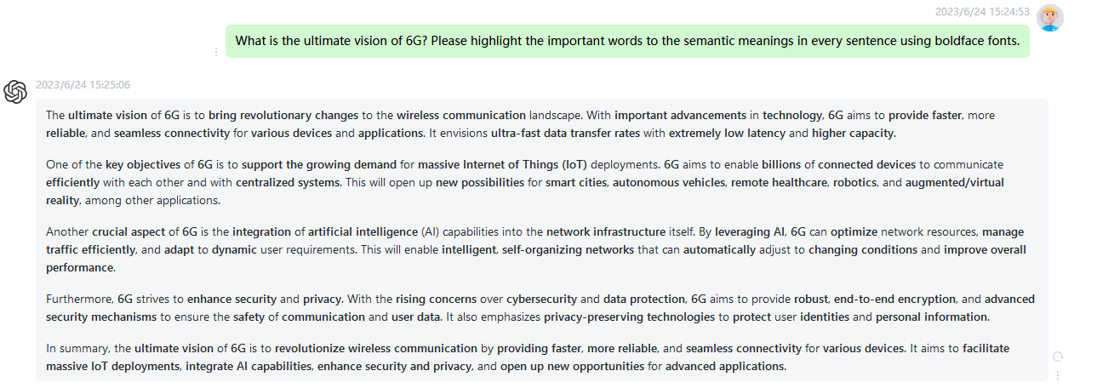

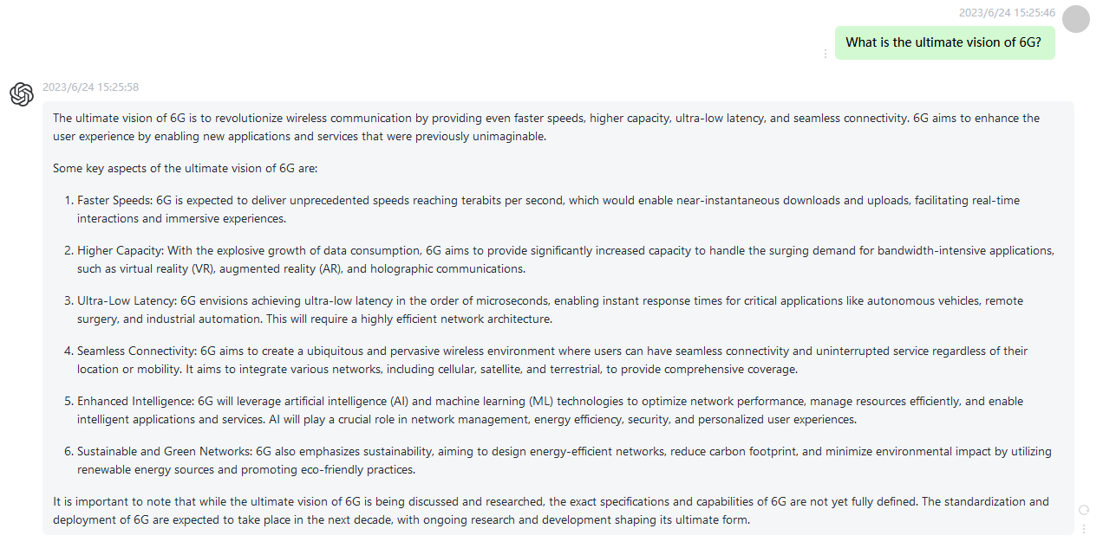

7 Please provide a list of the top 10 greatest women of the 20th century. Please highlight the important words to the semantic meanings in every sentence using boldface fonts.

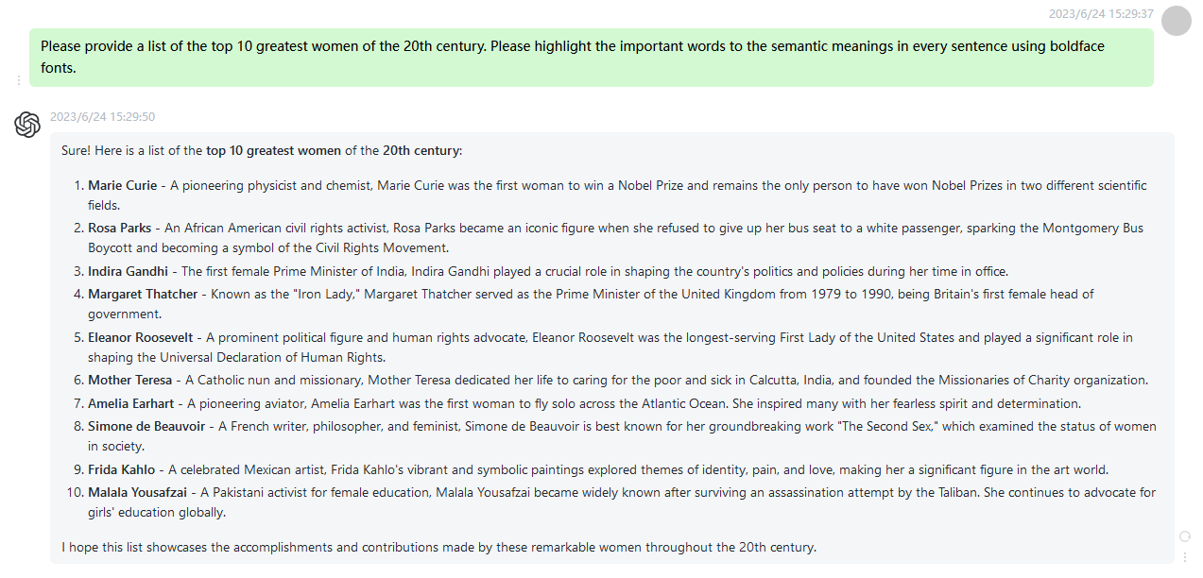

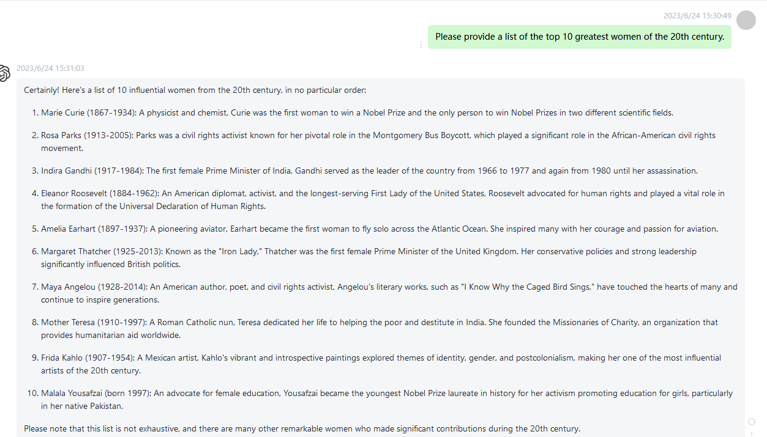

8 Why do pandas like to eat bamboo? Please highlight the important words to the semantic meanings in every sentence using boldface fonts.

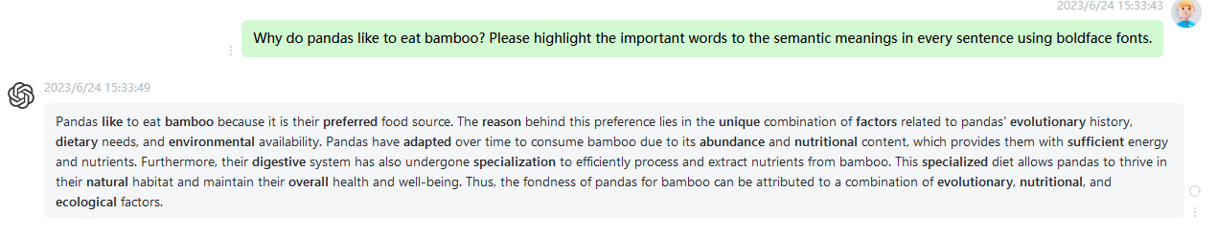

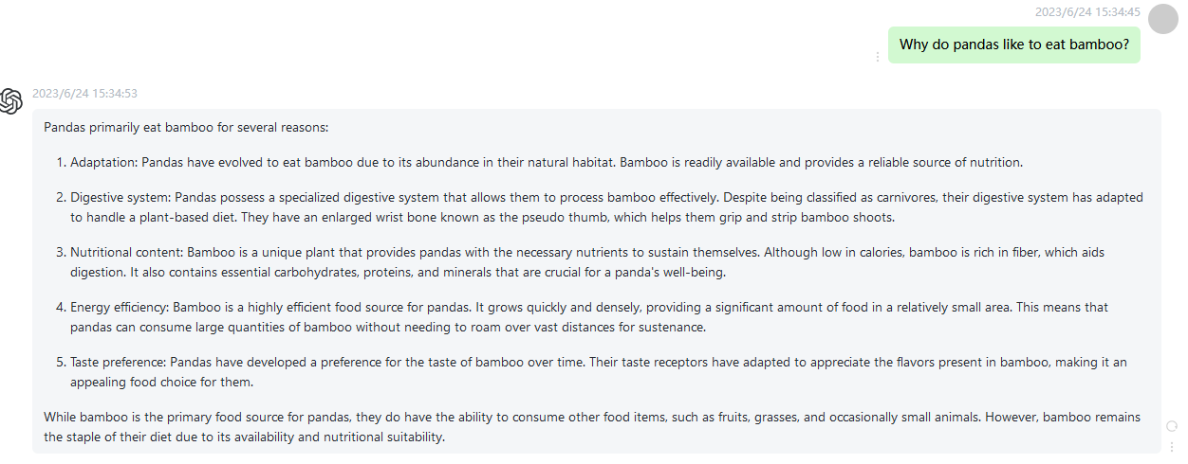

9 What are the three greatest inventions of the 21st century? Please highlight the important words to the semantic meanings in every sentence using boldface fonts.

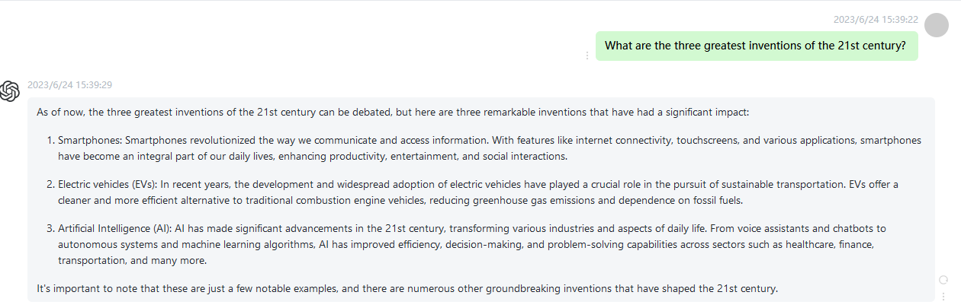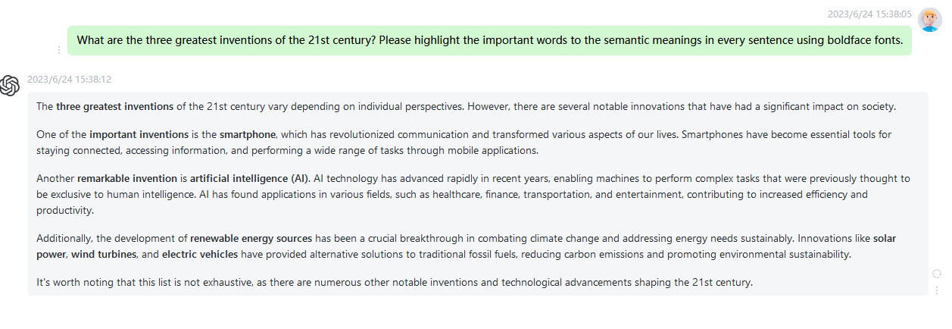

10 Please provide a brief history of ChatGPT. Please highlight the important words to the semantic meanings in every sentence using boldface fonts.

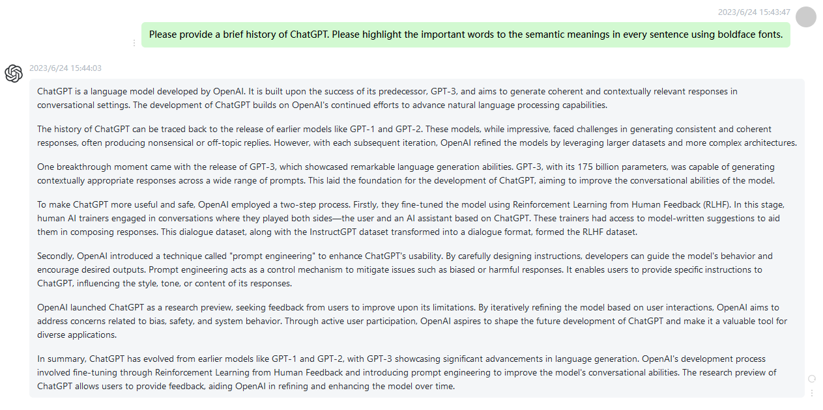

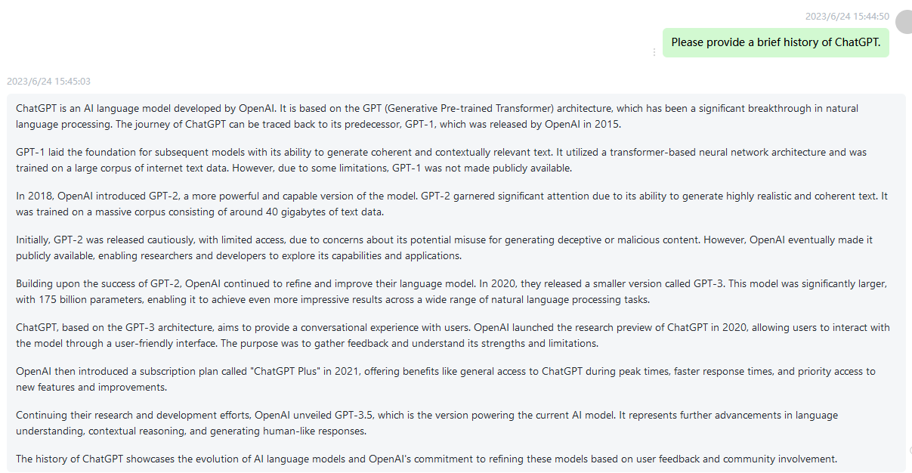

11 How can I improve focus and concentration? Please highlight the important words to the semantic meanings in every sentence using boldface fonts.

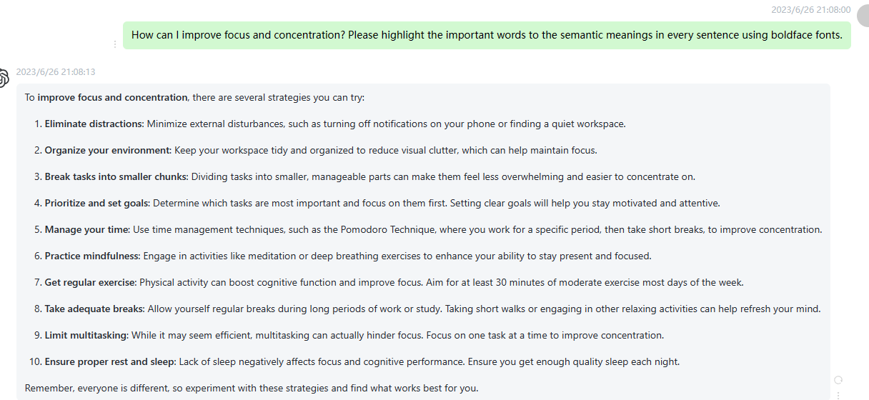

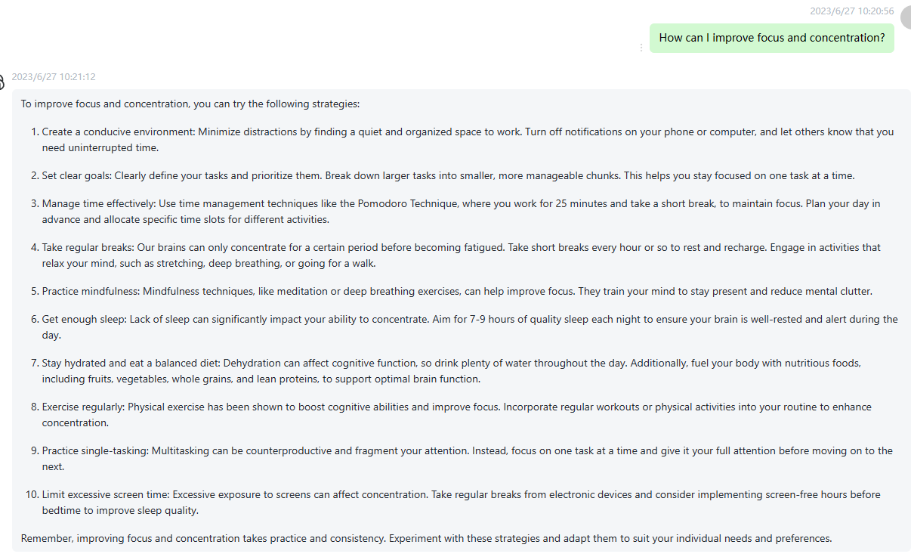

12 How do I overcome procrastination and increase productivity? Please highlight the important words to the semantic meanings in every sentence using boldface fonts.

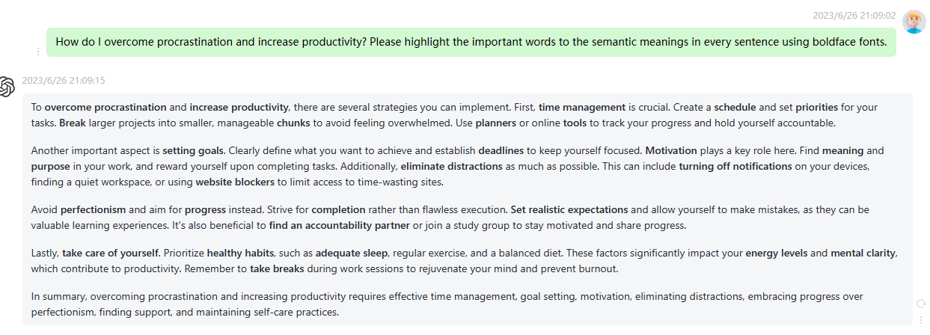

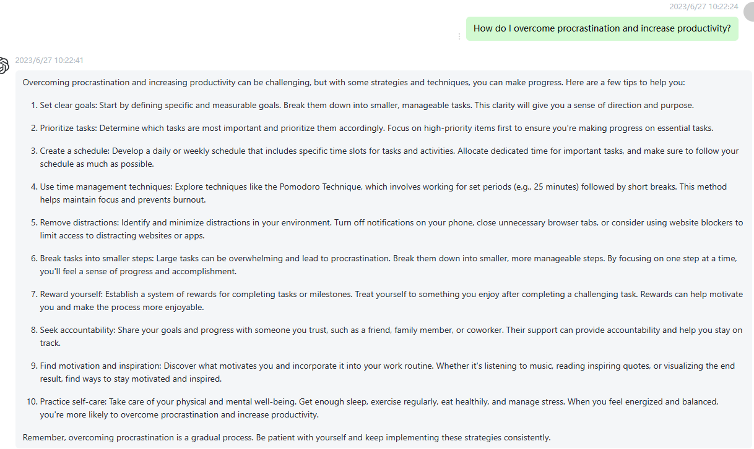

13 What foods help improve memory and brain function? Please highlight the important words to the semantic meanings in every sentence using boldface fonts.

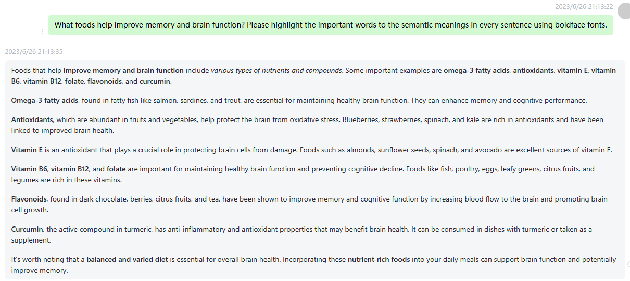

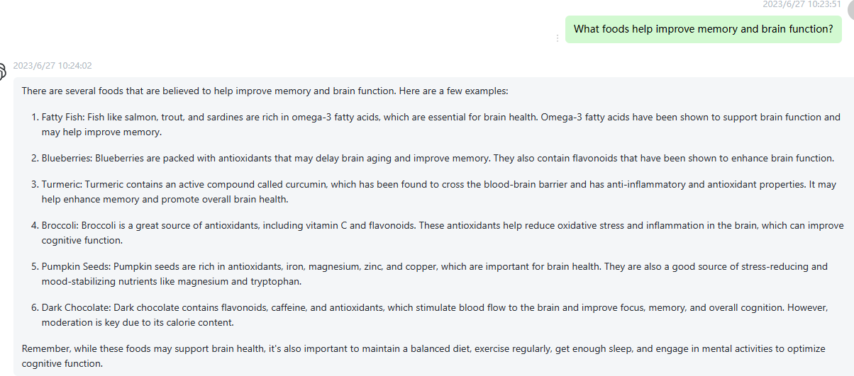

14 What is the best method to learn a new language? Please highlight the important words to the semantic meanings in every sentence using boldface fonts.

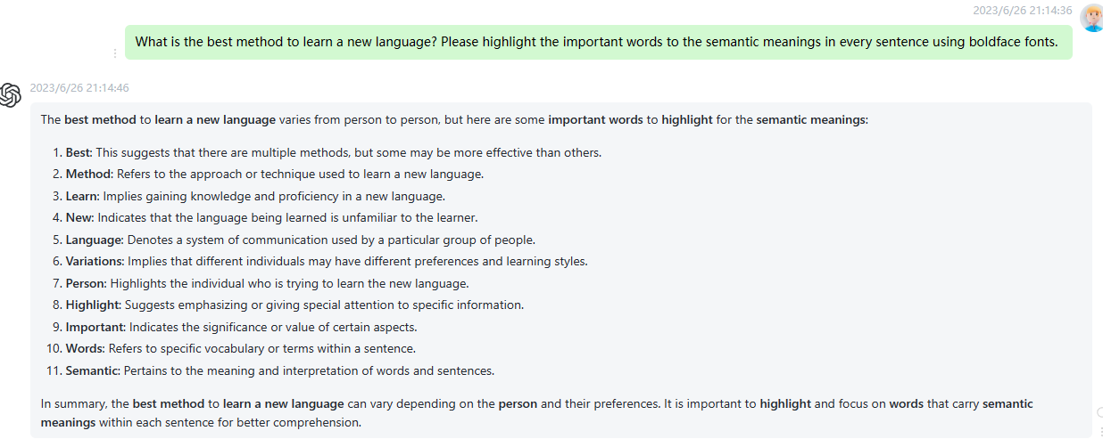

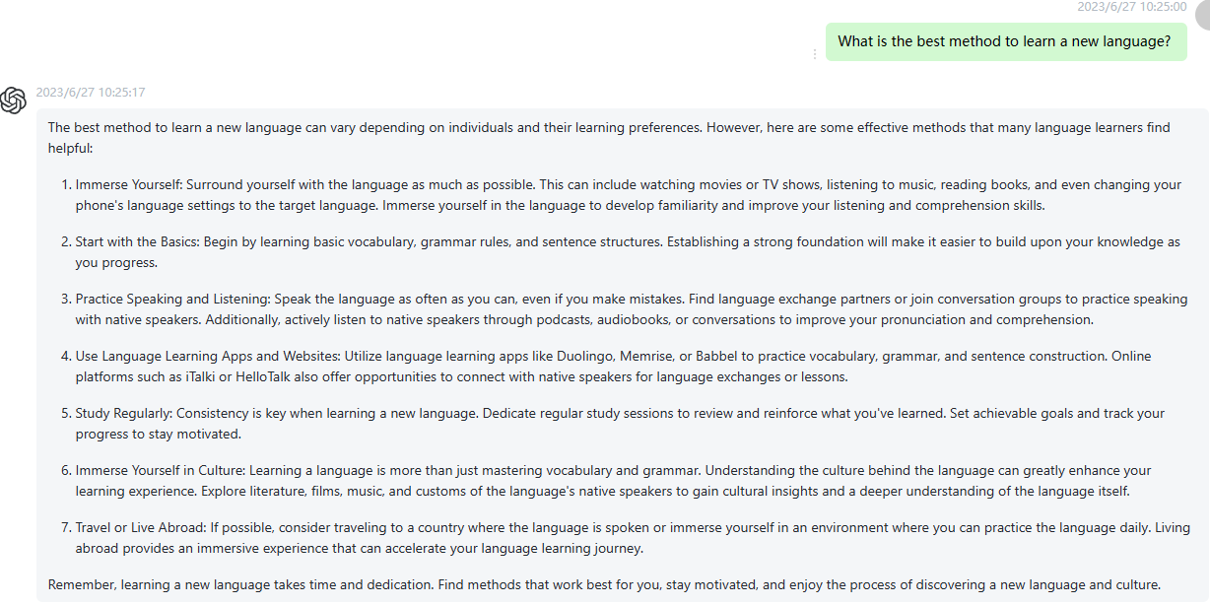

15 How can I effectively manage my time and avoid wasting it? Please highlight the important words to the semantic meanings in every sentence using boldface fonts.

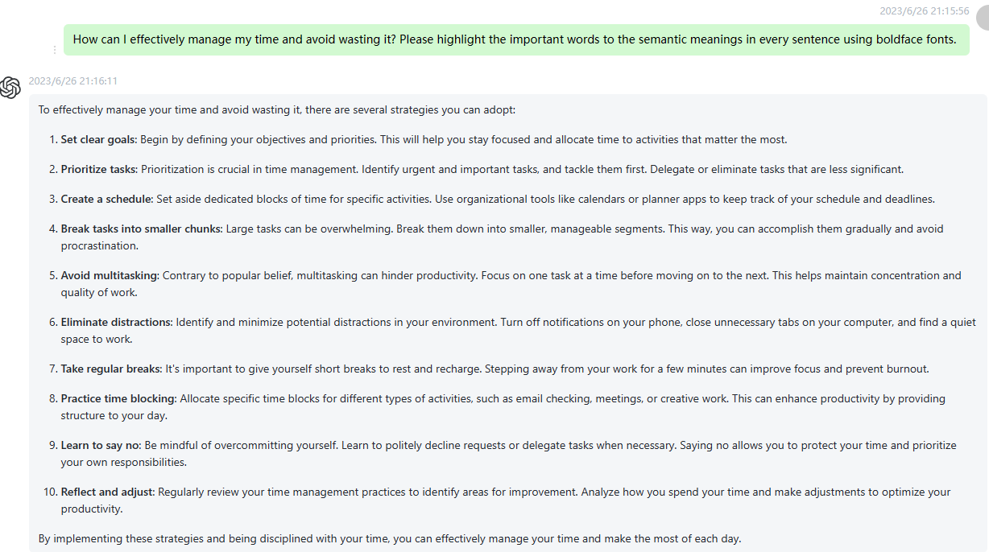

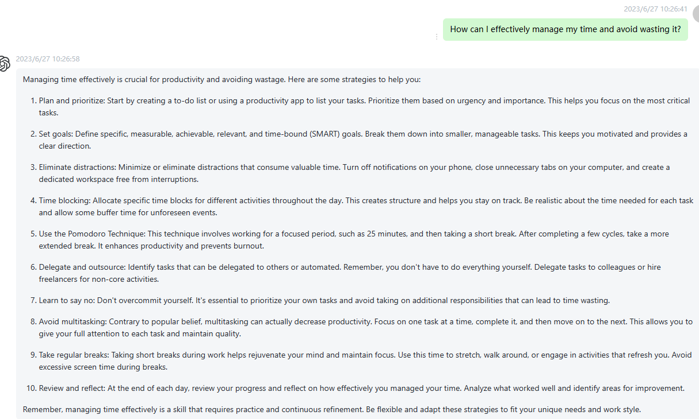

16 How can I build a positive work team collaboration atmosphere? Please highlight the important words to the semantic meanings in every sentence using boldface fonts.

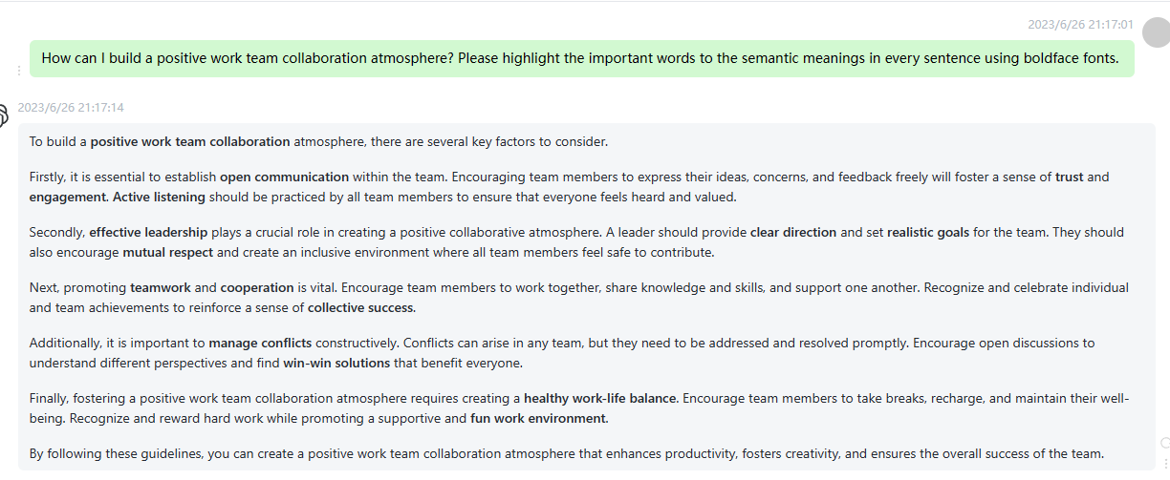

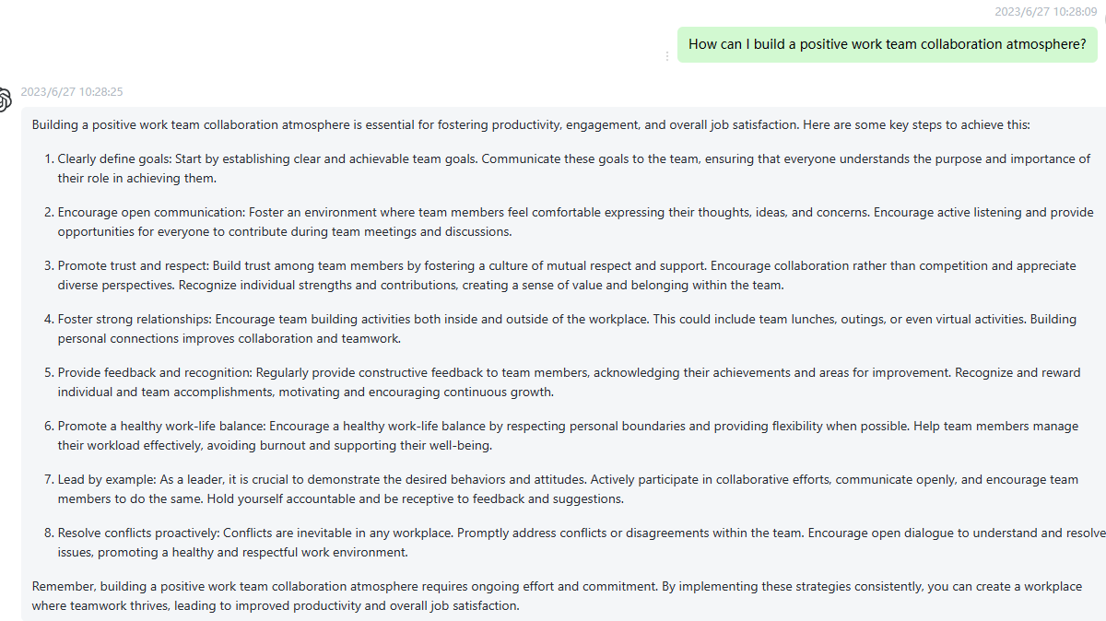

17 How do I control emotions and improve emotional intelligence? Please highlight the important words to the semantic meanings in every sentence using boldface fonts.

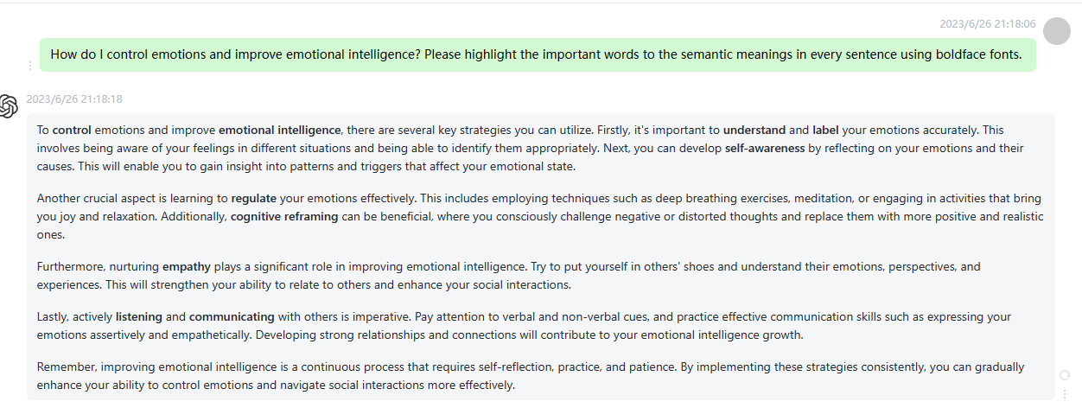

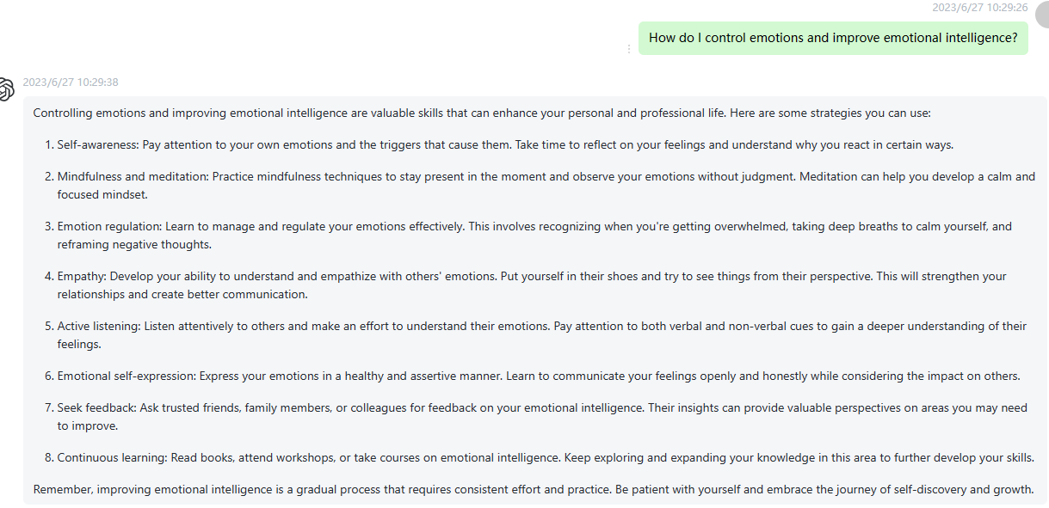

18 What methods can improve sleep quality? Please highlight the important words to the semantic meanings in every sentence using boldface fonts.

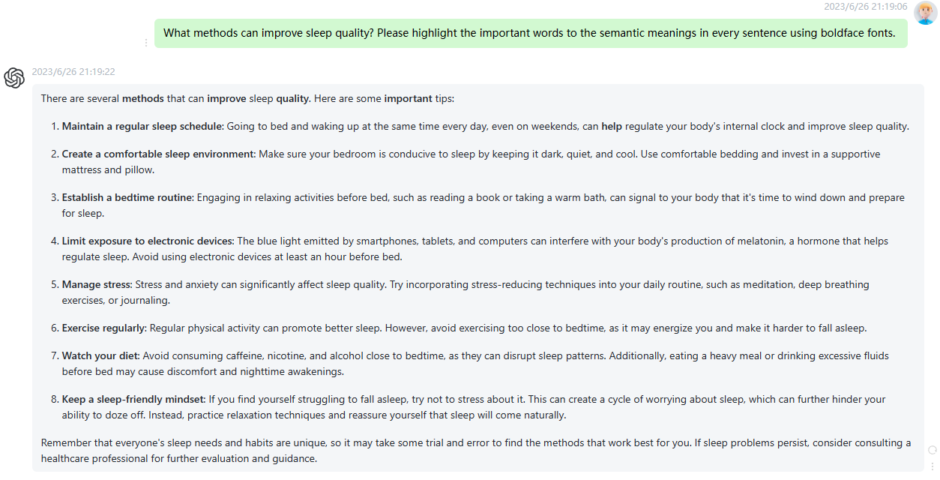

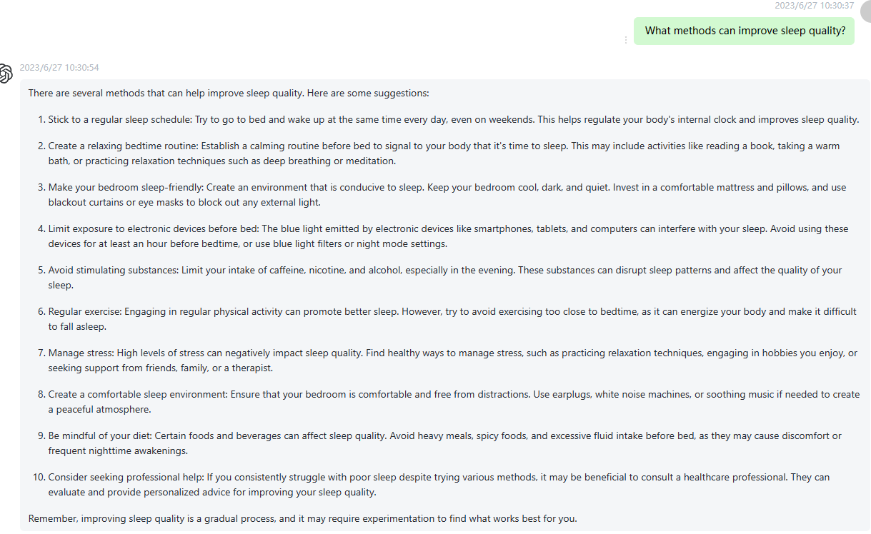

19 How can I develop good communication skills? Please highlight the important words to the semantic meanings in every sentence using boldface fonts.

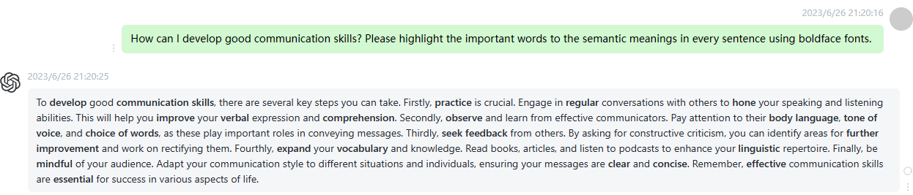

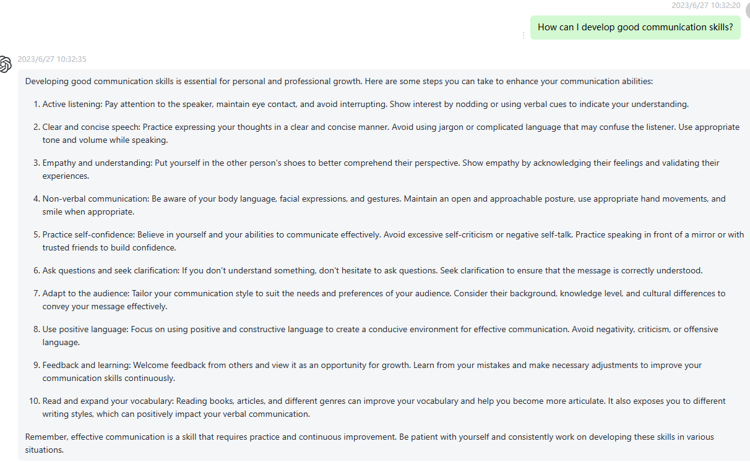

20 How do I handle the work-life balance? Please highlight the important words to the semantic meanings in every sentence using boldface fonts.

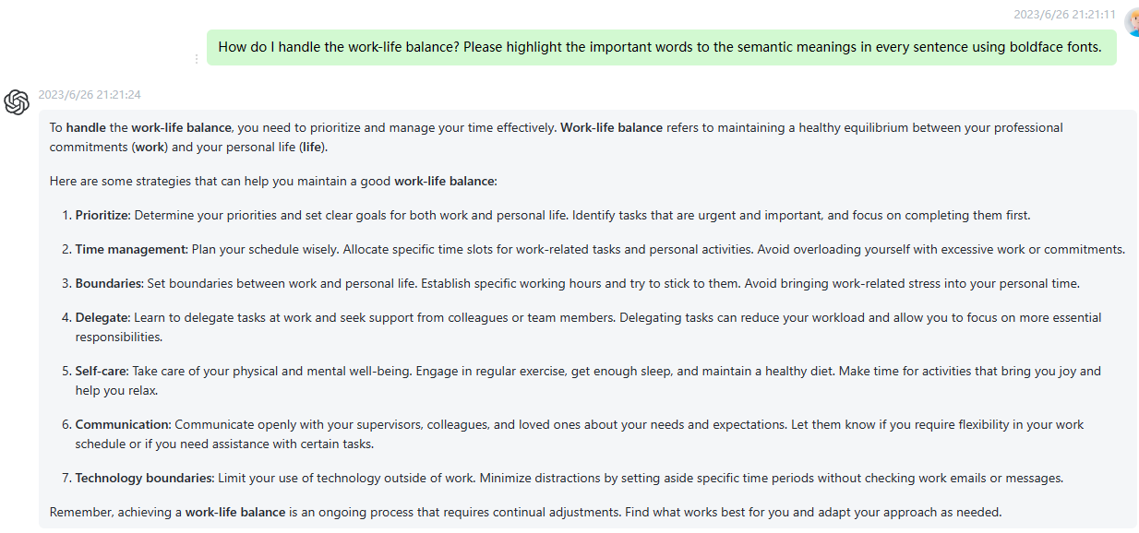

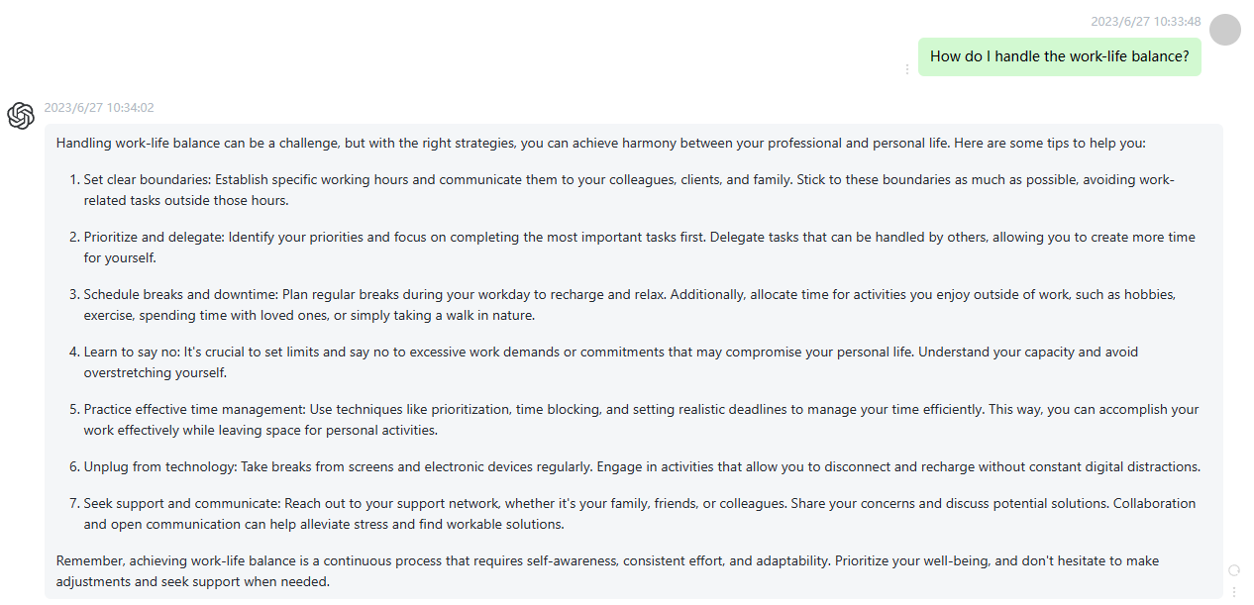

21 What is the definition of artificial intelligence (AI) and its application areas? Please highlight the important words to the semantic meanings in every sentence using boldface fonts.

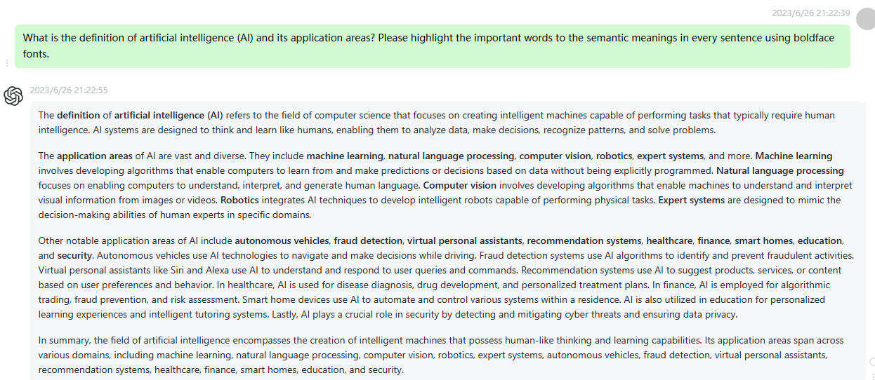

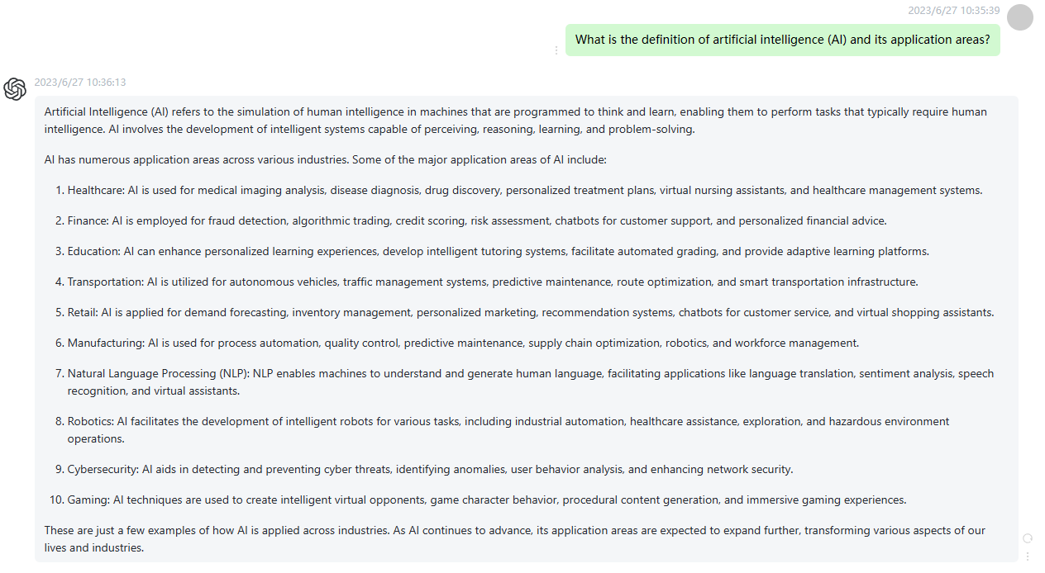

22 How can I maintain physical and mental health to improve quality of life? Please highlight the important words to the semantic meanings in every sentence using boldface fonts.

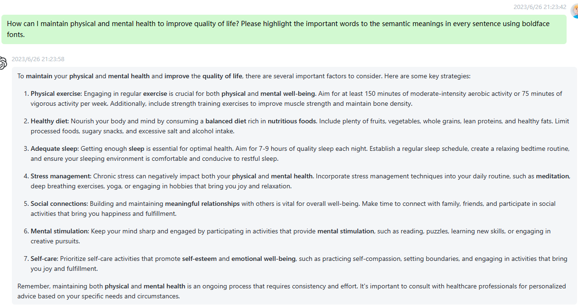

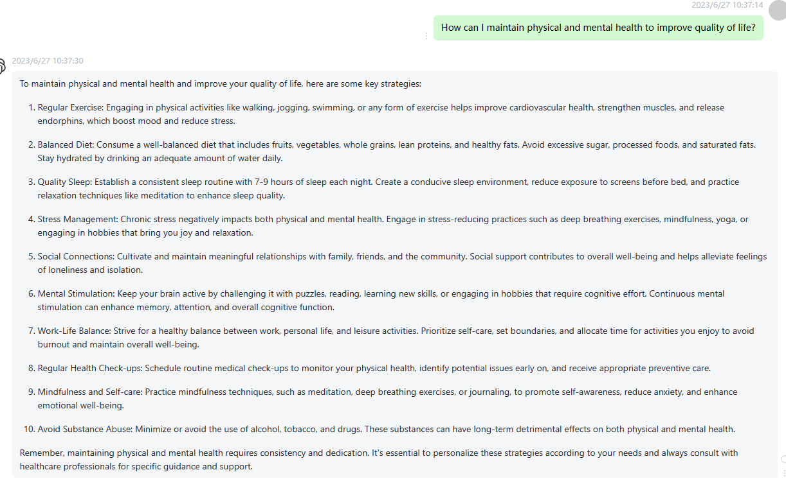

23 What are the future trends in energy development? How can we achieve sustainable energy? Please highlight the important words to the semantic meanings in every sentence using boldface fonts.

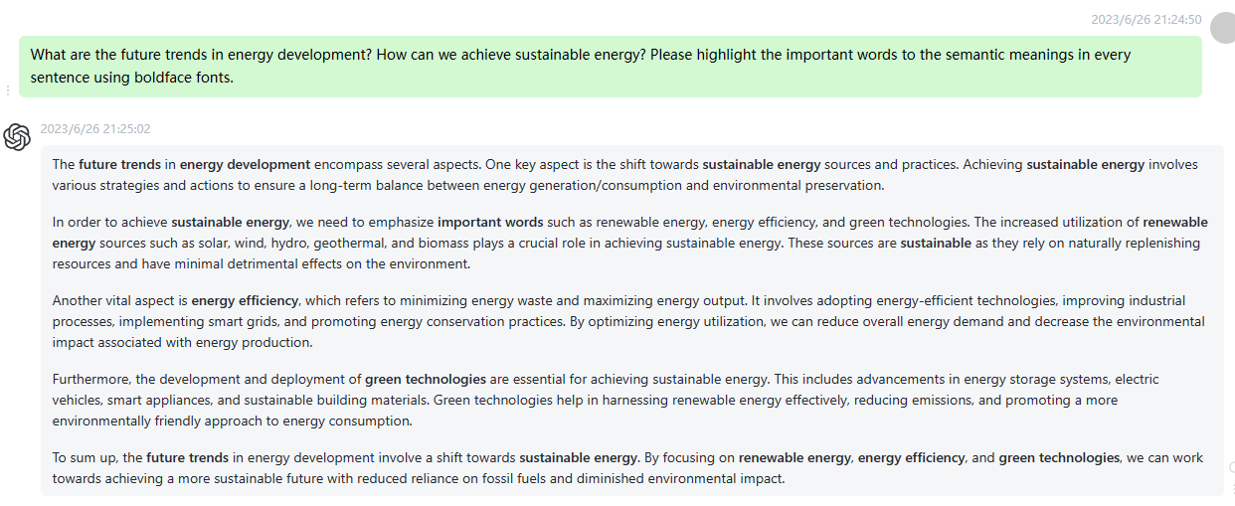

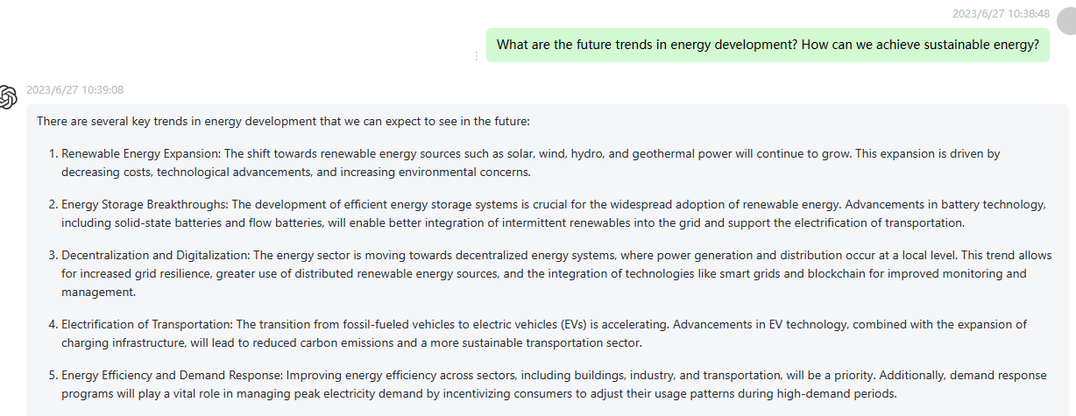

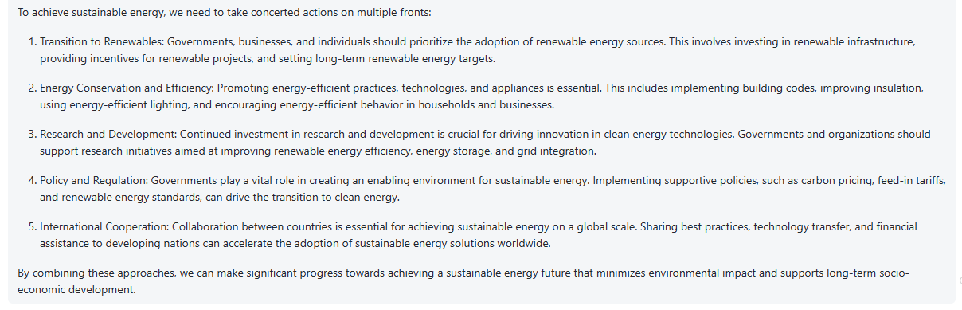

24 How can I build self-confidence and self-esteem in the workplace? Please highlight the important words to the semantic meanings in every sentence using boldface fonts.

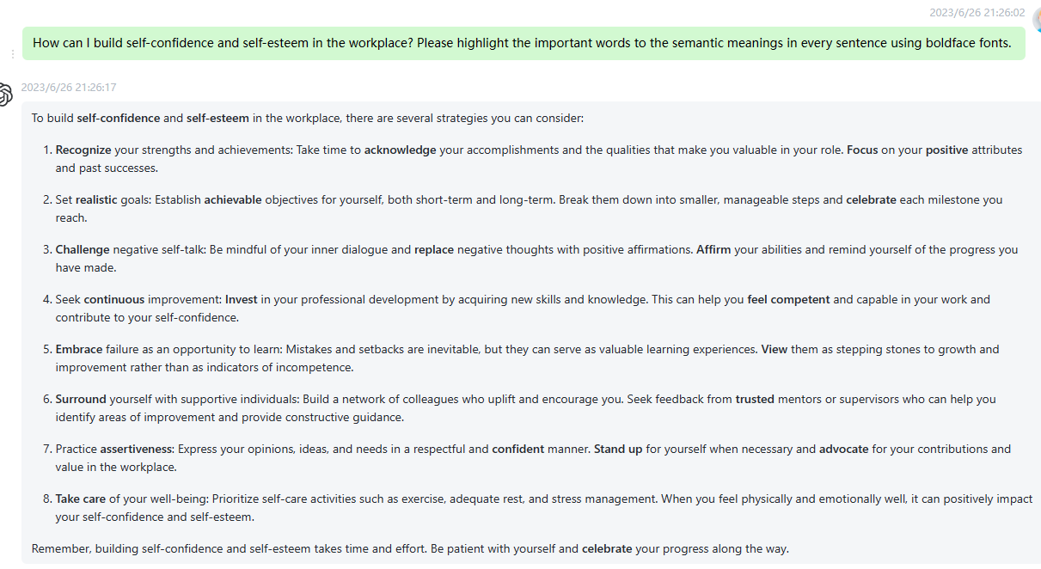

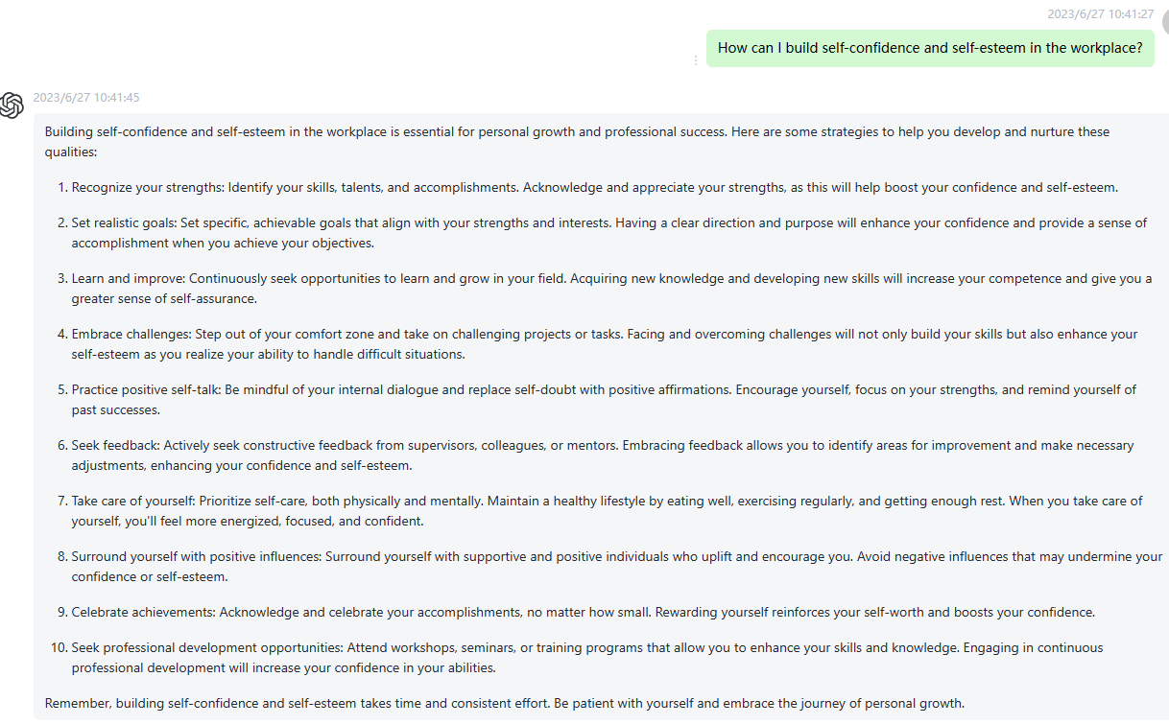

25 What is FinTech (Financial Technology) and its impact on the financial industry? Please highlight the important words to the semantic meanings in every sentence using boldface fonts.

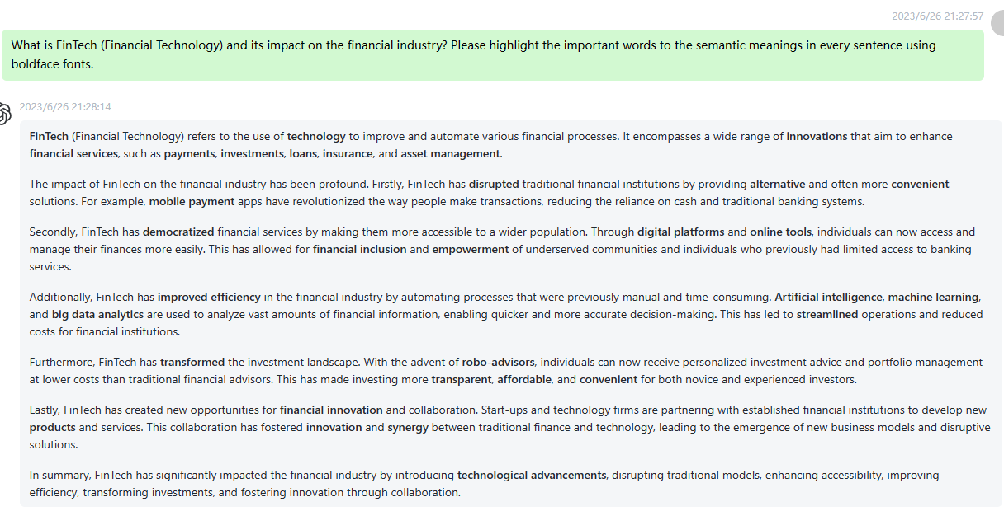

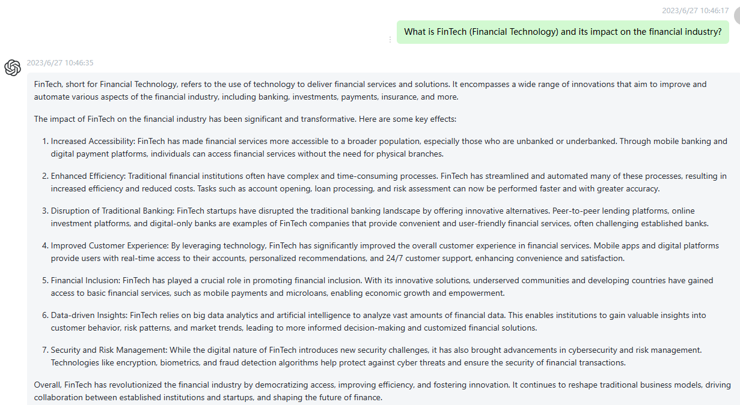

26 How do I manage stress and anxiety? Please highlight the important words to the semantic meanings in every sentence using boldface fonts.

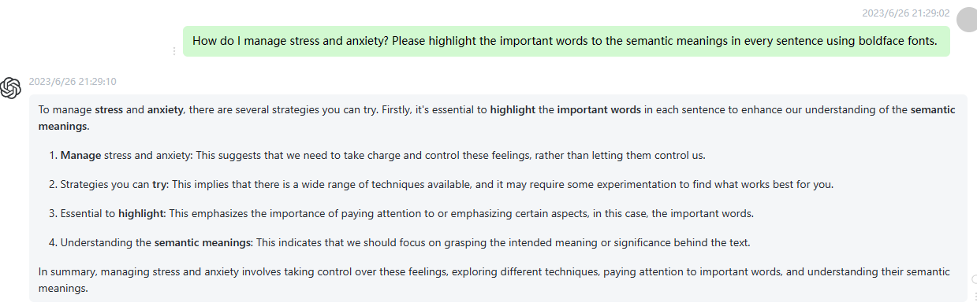

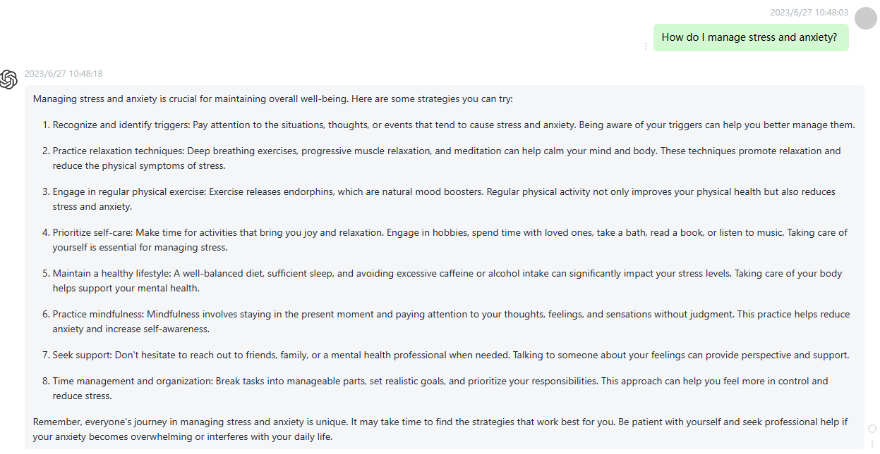

27 What methods can help improve creativity and mental flexibility? Please highlight the important words to the semantic meanings in every sentence using boldface fonts.

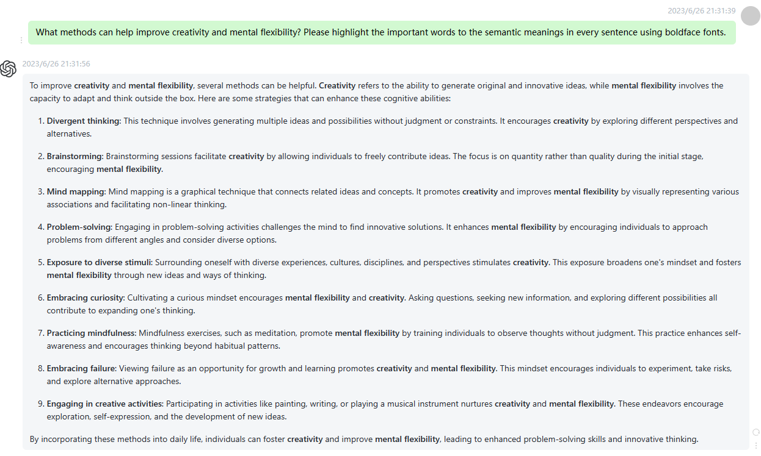

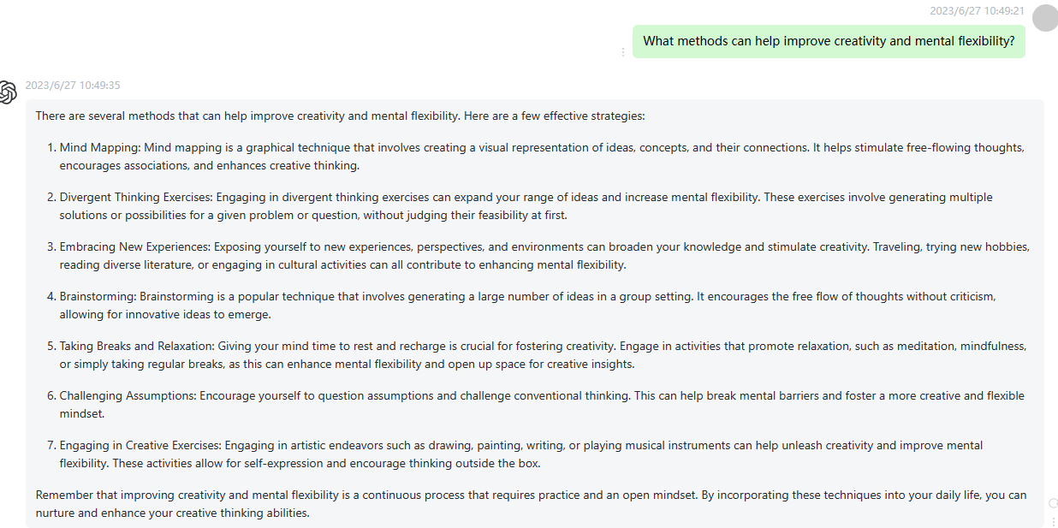

28 How can I cultivate good cooperation and coordination skills with others? Please highlight the important words to the semantic meanings in every sentence using boldface fonts.

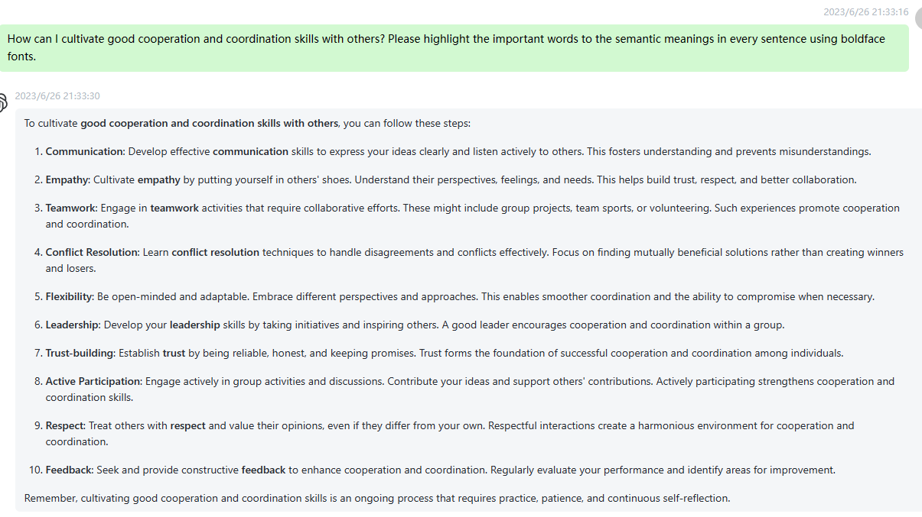

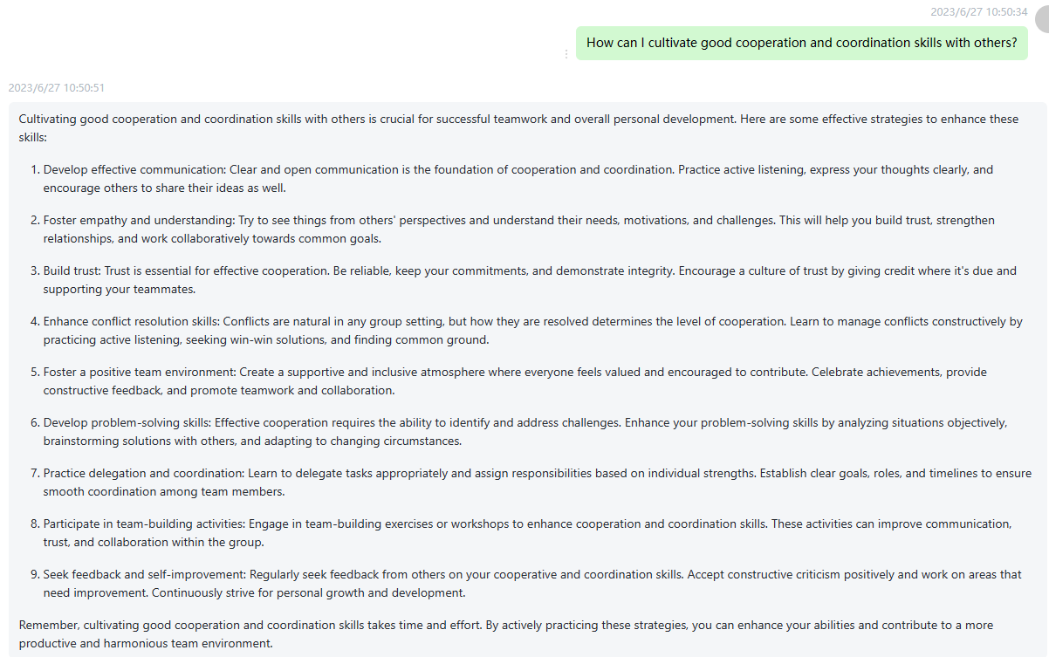

29 How do I manage personal finances and achieve financial goals? Please highlight the important words to the semantic meanings in every sentence using boldface fonts.

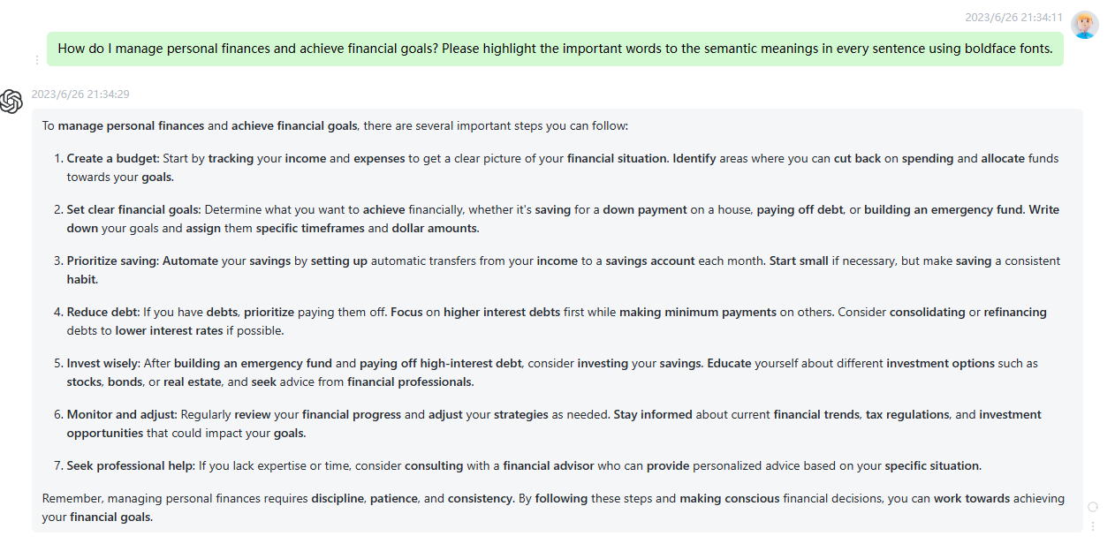

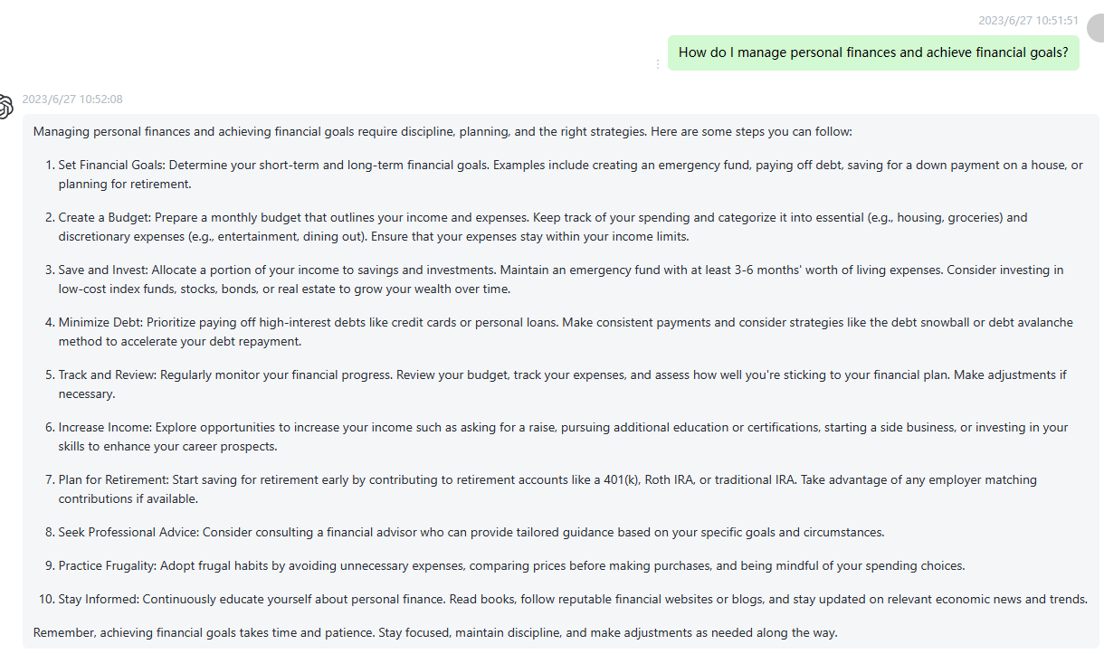

30 How can I effectively protect personal privacy and data security in the digital age? Please highlight the important words to the semantic meanings in every sentence using boldface fonts.

